**FOR WEB**

* **Without using principles of menu design and guidelines**

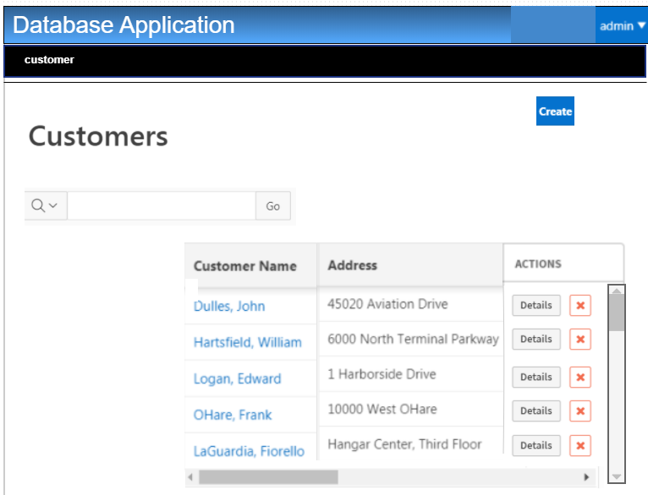

* **Using principles of menu design and guidelines**

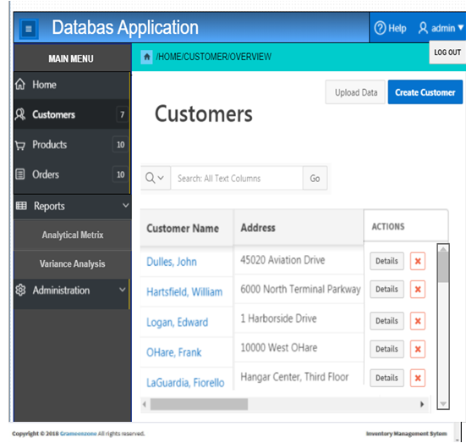

**For Web based projects:**

1. Explain the menu and navigational scheme used in your project? How effectively the menu and navigational scheme has been designed?

* In above given web project navigational menu are provided like global navigation and portlets menu to easy access things also through this or inside this horizontal drop down menu used for navigation and also we use it efficiently like just a an efficient left vertical navigation bar. Other things like create use and search are mandatory direct links to search and create.

1. Were there any menu navigation aids been provided in your project?

* Yes, I have provided menu like left vertical navigation menu bar and within horizontal drop down navigation menu and portlets navigation menu.

1. Is your design supports requirement of novice as well as expert users? If yes, how?

* Yes**,** our design is perfect for novice and expert using valuable navigation menu and mandatory links we provided a user too access each and thing easily and properly understand it easily and easy to use.

**FOR GUI**

* **Without using principles of menu design and guidelines**

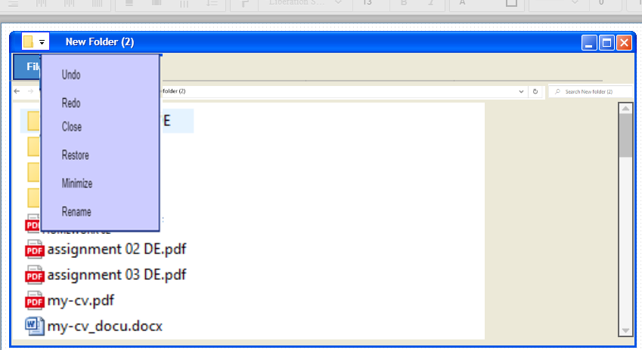

* **Using principles of menu design and guidelines**

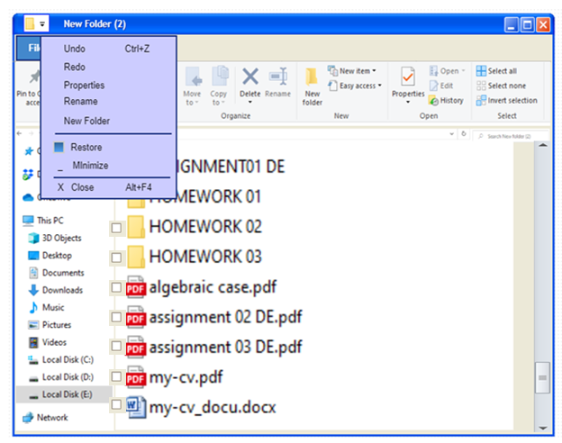

**For GUI based projects:**

1. Which of the available menu structure used in your project? Justify you answer.

* Horizontal Drop-Down Navigation, Portlet-Ready Navigation, Mandatory Links Only are used in my GUI project, Horizontal Drop-Down Navigation used in for making actions like close ,minimize undo and redo with proper short cuts and separators, indicators etc. and also all GUI need are full filled which are mention in lab manual. Portlet-Ready Navigation used in to directly access the files and Mandatory Links Only for search and going back, cut, copy, paste direct links etc.

1. What all features have been added to your menu to assist the user in developing a mental model of the system? Explain with respect to your project

* Yes, it assist all types of users, mental model of different people are different and people perceive it differently and some people are really not clear in their mind what they exactly want so it’s really close to their mental model also easy to use for any user my clicking on different option they can easily learn how to edit, delete, rename, copy, paste, undo, redo, create new folders & files.

1. Is your design supports requirement of novice as well as expert users? If yes, how?

* Yes our designing is fulfilling all the demands of the novice as well the experts because its fulfilling all the needs of both experts and novice novice easily use it from simple short cut on screen and experts use it easily using shirt keys easily access files and documents using indicators.